d The project application must be approved before the work commences on the project. Expenses incurred before the project application is approved are not eligible for reimbursement.
e. Submittal of two 8 by 10 “after” color photo- graphs upon completion of project and to ensure reimbursement.
- The program functions on a reimbursement basis. The property owner can request reimbursement for pre
-approved project expenses by submitting a reimburse- ment request form with proof that the expenses have been paid to the contractor or supplier.
- Any changes in the scope of work included in the approved application must be pre-approved by the FIP Review Committee. Deviation from an approved plan may disqualify the applicant from the grant program.
- Projects must be completed no later than December 31st of current awarded year for the February 1st application deadline. Projects must be completed no later than December 31st of the following awarded year for the July 1st application deadline. Any change in the project scope from the original application must be ap- proved by the FIP Review Committee.



Mapped Area of
Façade Improvement Concentration for Downtown Area (see below).
Menekaunee Area of Ogden and Hosmer is included but not mapped.

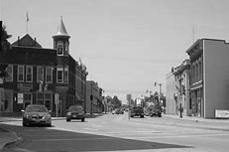

Community Development Office 1905 Hall Avenue
Marinette, WI 54143-1716
715.732.5139
jkust@marinette.wi.us
T h e C i t y o f M a r i n e t t e
Façade Improvement Program
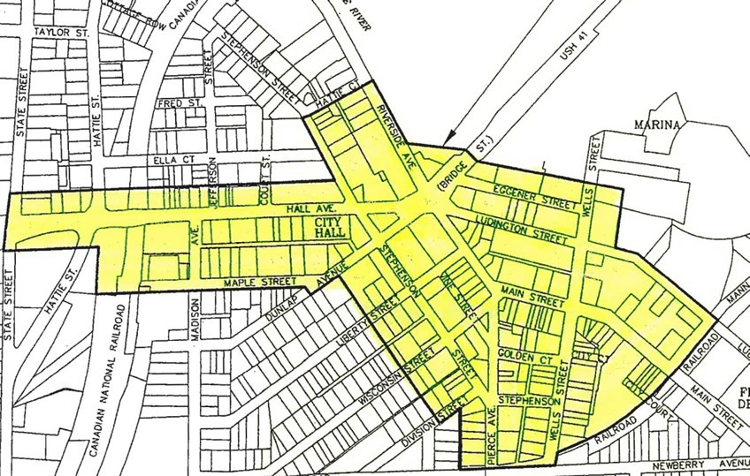

The City’s financial participation shall be limited to 50% of the rehabilitation costs up to a maximum per project of $25,000.00. Property owners may receive such assistance from the City once in a three-year period per building. The same property owner may apply for another building which also seeks City participation. The availability of funds for the FIP is subject to annual appropriation of $50,000.00 or additional appropriation by the City Council. Awards for assistance under the program will be made on a first come first served basis. The deadlines for applications will be Feb. 1st and July 1st of each year. If funds are not committed to the FIP by Feb.1, for projects in the down-town area, funds may then be used for : 1) projects throughout the City, consistent with the intent of the program, with preference given to those projects having the greatest direct or indirect impact on the downtown program area, 2) projects undertaken by the City to improve the downtown area.
The City of Marinette Façade Improvement Program Revised 2024

The goal of the Facade Improvement Pro-gram (FIP) is to encourage improvements that stress the historic significance and uniqueness of downtown structures through building restoration.
The City of Marinette is interested in actively supporting initiatives that will enhance the appearance of the downtown area and the retail/commercial areas near Menekaunee Harbor that include businesses along Ogden and Hosmer Streets. (The downtown area includes the streets shown on the map with the brochure.)
The City has established the Façade Improvement Program (FIP) to provide financial assistance to commercial property owners in the downtown area to rehabilitate the exteriors of their properties. The City’s financial assistance is designed to enhance the historical character of the downtown area by providing financial incentives to property owners whose rehabilitation plans seek to restore some of the historic character to their properties.
Preference will be given to historic buildings, however, other buildings may be eligible but all awards will be at the sole discretion of the selection committee. Preference will also be given to those who have not applied previously. The selection committee is composed of the following: Historic Preservation Chairman, Plan Commission Chairman, a Representative of the Commu-nity Development Office, City Engineer, Finance Committee Chairman and the Finance Director.

Funds may only be used for exterior repairs or improvements.
  - Eligible Improvements:
- Repair to building exterior facades including front, rear and side facades.
- Masonry repair and tuck pointing.
- Cleaning of building exterior.
- Exterior painting.
- Repairing or replacing cornices, entrances, doors, windows, decorative details and awnings.
- Signage removal, repair or replacement when included as part of a comprehensive façade improvement project.
- Other repairs that may improve the aesthetic quality of the building.
- Removal of metal or wood material covering historic facades.
- Other labor and materials used to rehabilitate the
façade. In cases where property owners hire a con-tractor to complete the work, the contractor must be licensed and registered with the City of Marinette or approved through the Façade Improvement Committee.

Ineligible Improvements:

- Interior improvements.
- Roofing and parking lots.
- Inappropriate cleaning methods, repairs, replacements.
- Installation of metal, vinyl siding.
- Demolition of buildings.

Grant Policy:
The City will not discriminate against any con- tractor/ consultant because of age, race, reli- gion, color, handicap, sex, physical condition, developmental disability as defined in S.51.01 (5). Wis. Stats., sexual orientation or national origin.

Program Implementation:
- Application Implementation:
  - The applicant must submit a completed
application by the February 1st or July 1st deadlines. Please call the Community Development Office 715.732.5139 to request an application or go online to: www.marinette.wi.us.
  - The application must include plans which show: 1.) All proposed work, including any structural work or repairs; 2.) Price quotes from two retail suppliers for projects that involve material costs only and no labor costs; 3.) A schedule for completion of the project; 4.) Samples of paint colors must be included in the application and; 5.) Samples of other materials may be requested as part of the project review.
  - The application must include two 8x10 "before" color photographs.

